In this lab we sill create a VM Instance using GCP console and we will also login to the VM

**Once lab is completed, also explore stop, start and delete VM options.**

# Create VM

1. First select the project where you want to create VM
2. At hamburger menu go to Compute engine>VM Instances

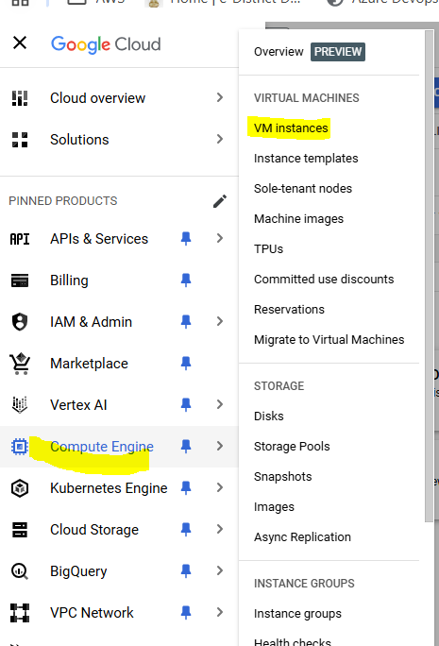

1. For first time creation, we need to enable Compute engine API, so click Enable

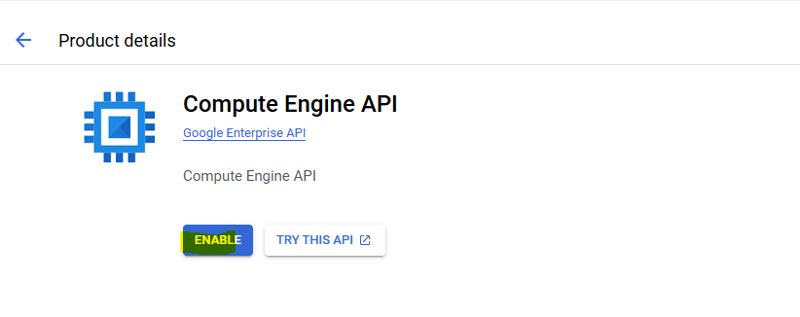

1. Here we can see list of our existing instances, to create new click “Create Instance” button

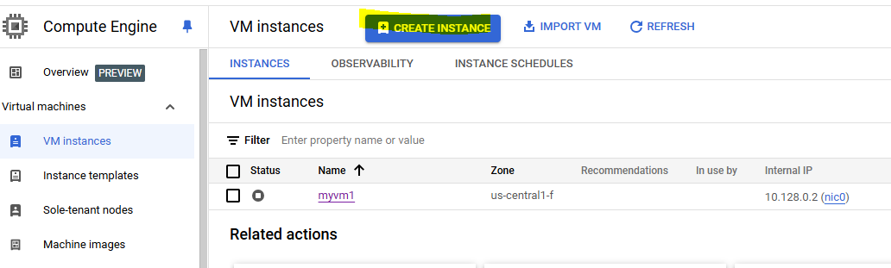

1. Give instance a name, select region and zone
2. Select shape

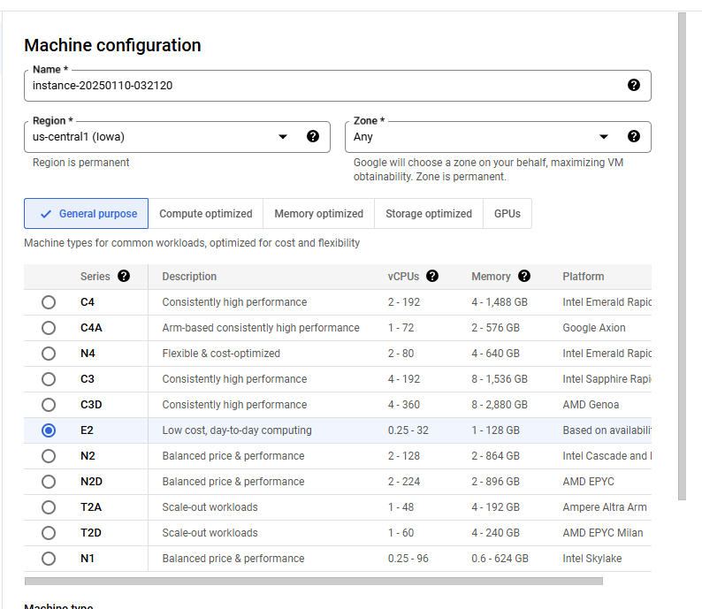

1. Keep rest details default and click create

## Connect VM

**Note:-** In this section we will only check connecting to vm directly via browser. In coming sessions and another lab we will also connect to vm via putty tool using ssh key.

1. Make sure Instance is at running state

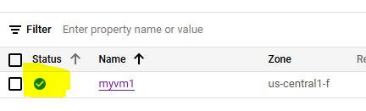

1. Go to ssh option and click open in browser

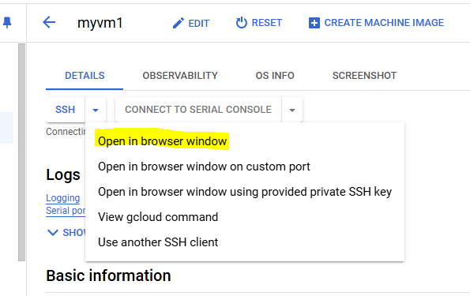

1. A new window will open, click “Authorize” button if asked

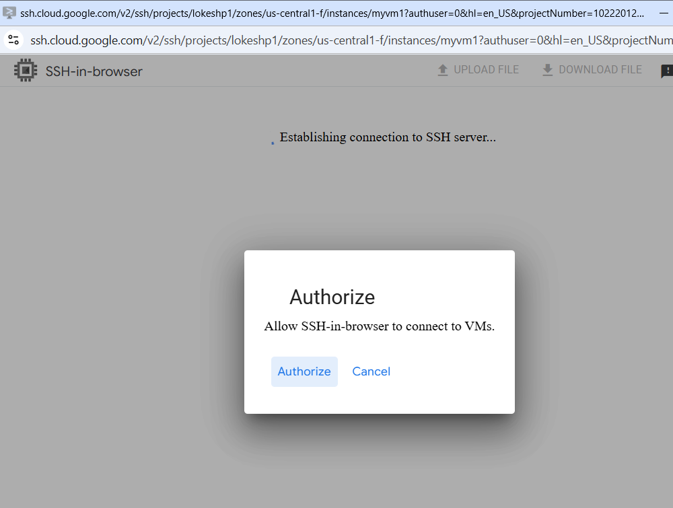

1. Now you have logged in to the vm

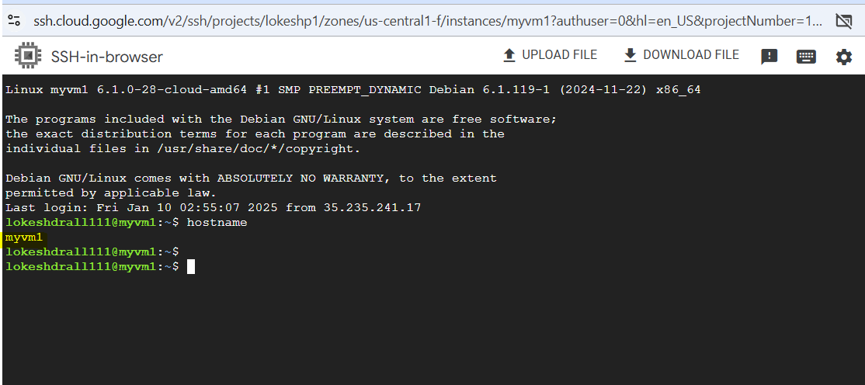

**Once lab is completed, also explore stop, start and delete VM options.**